IDE Infrastructure Design

6 January 2015

Below are examples of rainfall exclusion shelter designs for use in short-stature systems.

1. Example from Chihuahuan desert: 6.25 m² plot
   1. Rainout shelters consist of a metal frame supporting V-shaped clear acrylic shingles
      1. For stability, 150 cm rebar is buried 75 cm into the soil at four corners where the shelter will rest
      2. Shelter frame is constructed using electrical metal conduit
         1. mean height of shelter was determined by taking into account the mean height of the shrubs which were going to be covered
            1. in this case, 50 cm
         2. two sets of uneven bars on opposite sides of the plot
            1. higher end of frame 113 cm tall
            2. lower end of frame 45 cm tall

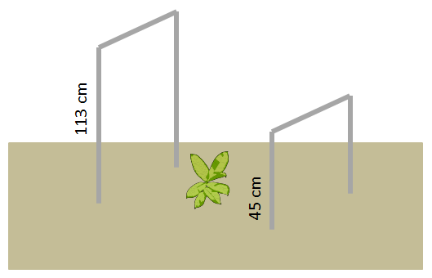

* + - 1. angle of roof inclination will be 20°
      2. higher end of frame should be oriented toward the equator to maximize the amount of direct sunlight able to reach plot
    1. Conduit bars of the frame slide over the exposed rebar in the ground and are tied down with wire
    2. Shingles are constructed by purchasing acrylic from Regal Piedmont Plastics, LLC, El Paso, TX
       1. order pre-cut into strips 254 cm long and 12.7 cm wide
       2. using a Straight Line Bender, heat the plastic strips and place them into a wooden 120° angle mold to cool
       3. shingles are then hand-tightened onto the frame with nuts and bolts
    3. A gutter is attached to the lower end of the shelter
       1. 4” diameter 10-foot PVC pipe cut nearly in half
       2. an un-cut span is left on one end of the gutter as a splash guard
       3. design allows for two gutters per PVC pipe

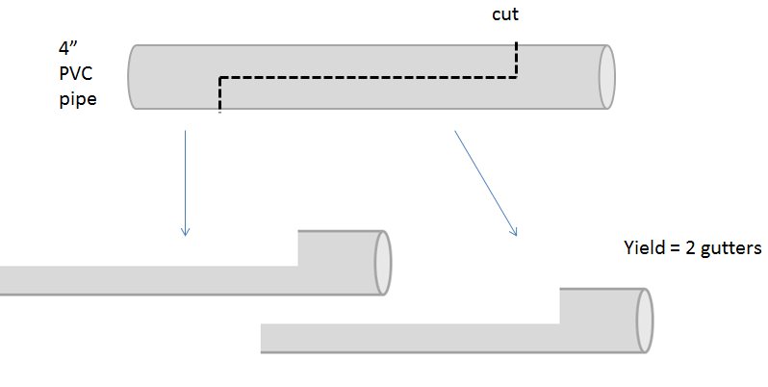

* + - 1. gutter installed onto frame at a slight angle to facilitate draining
    1. Draining end of gutter
       1. 4” PVC cap drilled with a hole on one side
       2. plastic barb fitting is glued into the hole
       3. braided PVC hose is clamped onto the barb
       4. hose end is deposited into collection tank or away from the plot for drainage

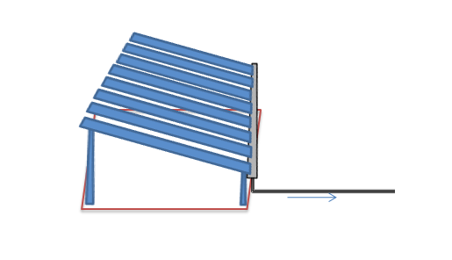

1. Cost breakdown in 2011 USD
   1. Frame
      1. rebar: $12
      2. electrical metal conduit: $18
      3. elbows: $18
      4. gutter: $20
      5. bolts and nuts: $10
      6. wire (2.5 m per shelter): $2
   2. Shingles
      1. for 50% interception (11 acrylic strips): $83
      2. for 80% interception (18 acrylic strips): $135
   3. Total
      1. for 50% interception: $213
      2. for 80% interception: $265
2. Larger shelters can be constructed by assembling small shelters as above and using them as modules
   1. A 6 m by 5 m shelter can be built using 4 modules
   2. A removable 1 m “gate” section in the middle of the large shelter allows walk-in access
   3. Hinges are used for easy opening and closing of the gate

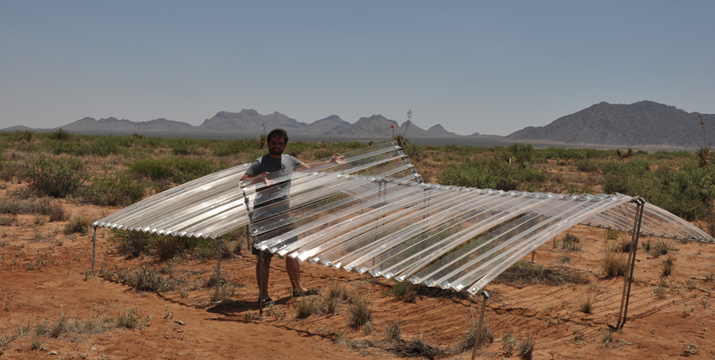

 **Fig. 2**. Example of a simple, passive precipitation reduction shelter that removes a fixed proportion of each rain event (blue dotted lines represent rainfall) from reaching experimental plots. This basic design, modified in scale and placement (i.e., below the canopy in forests), has been used successfully in a wide range of ecosystems.